

# Dear Parents/Guardians,

Roanoke City Public Schools will be administering MAP Growth assessment during the 2024 - 2025 school year.

Attached below is some information regarding MAP Growth.

An informational video can be found at:

https://[www.nwea.org/resource-center/resource/what-is-map-growth/](http://www.nwea.org/resource-center/resource/what-is-map-growth/)

How it works

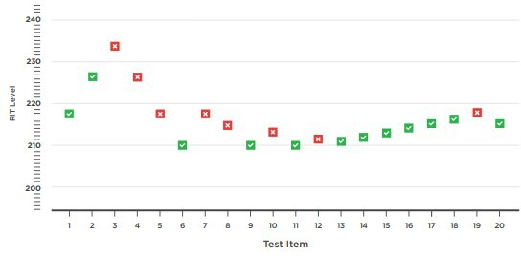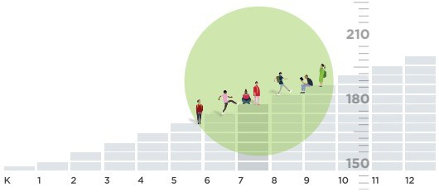

MAP Growth is a computer-adaptive test. If your child answers a question correctly, the next question is more challenging. If they answer incorrectly, the next one is easier. This type of assessment challenges top performers without overwhelming students whose skills are below grade level.

MAP Growth begins with a question at each student’s grade level and adjusts the level of difficulty based on individual performance.

What it measures

MAP Growth uses a RIT scale to accurately measure what students know, regardless of their grade level. It also measures growth over time, allowing you to track your child’s progress throughout the school year and across multiple years. Once your child completes a MAP Growth test, they receive a RIT score.

The RIT scale precisely measures student performance, regardless of whether they’re performing on, above, or below grade level.

Your student’s RIT score

RIT scores have the same meaning across grade levels. If a fourth-grade student and an eighth-grade student have the same RIT score in reading, then they are testing at the same level in that subject. This stable scale allows teachers to accurately measure each student’s academic growth throughout the school year and over time.

Feel free to contact me directly at 853-2101 if you have any questions. I am always here to support and assist you and your child in any way possible.

Sincerely,

Michael Trussell, Director of Data and Analysis