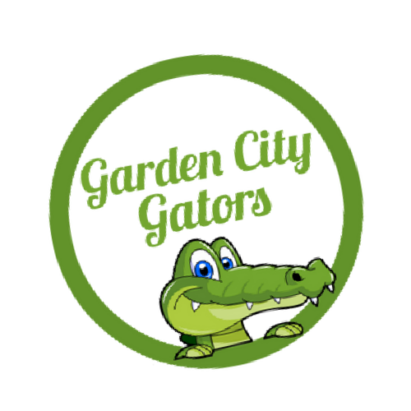

GARDEN CITY ELEMENTARY

SUPPLY LIST

**2nd Grade**

2 Boxes of Ticonderoga Pencils (they last longer than other brands. Two boxes will last your child the ENTIRE year).

4 Packs of BLACK ONLY (no colors) Expo Markers (These last much longer than other brands. These are for student use, not teacher use).

1 Pencil box/Pencil Pouch

1 Box of Crayons

1 Pair of Scissors

2 boxes of Tissues

1 Pack of Glue Sticks

1 pair of Headphones

1 Pack of Pencil Top Erasers

1 Box of Baggies (Boys – Gallon Size, Girls – Quart size)

1 Pocket Folder

**\*Please do NOT send the following\***

Markers

Pencil sharpeners

Notebooks/Binders

**4th Grade**

3 boxes of tissues

1 pair of scissors

1 box of 24 count crayons

1 composition notebook

1 1.5-inch binder

1 package of dividers

2 Highlighters

5 large glue sticks or 10 small glue sticks

4 boxes of 24 count #2 TICONDEROGA pencils, preferably pre-sharpened

1 pack of 8 count fine-tip (skinny) dry erase markers

2 packs of black fine tip Flair pens

1 packs of wide ruled paper

1 pair of Earbuds and 1 pair of headphones

1 Box of Band-Aids

1 container of Clorox wipes

1 pencil pouch

1 box of sandwich size Ziplock bags

**\*NO PENCIL SHARPENERS, MARKERS, OR PENCIL BOXES\***

**Pre- Kindergarten**

Disinfecting Wipes

Baby Wipes

Towel/Blanket

Hand Sanitizer

Ziploc bags – gallon size

Kleenex

Change of Seasonal Clothes

Backpack

**1st Grade**

48 Pencils- (Ticonderoga brand is preferred., they last way longer, and the eraser works well)

4 boxes - 2 count Crayola Crayons

1 box - 8 count of Crayola Markers

1 Marble Composition Notebook

Dry Erase Markers (Black EXPO marker)

24 Elmer’s glue sticks

1 Pocket folder (Plastic)

4 Boxes of Tissues

1 box - Quart slider baggies (BOYS)

1 box - Gallon slider baggies (GIRLS)

Hard pencil box

Headphones (not earbuds)

**3rd Grade**

**Must have:**

7 composition notebooks (NO SPIRAL BOUND)

2 plastic folders with pockets

1 pencil pouch or box (large enough to store crayons or markers)

**Choose 1:** Crayons (24 pack), Markers, or Colored pencils

**Items to be used as classroom community:**

Scissors

4 packs of pencils

1 package cap erasers

2 packs of black dry erase markers (any size)

4 packs of Glue sticks

1 ream of copy paper or cardstock (any color)

Highlighters

Items to donate for classroom wellness:

Band-Aids

quart Ziplock bags (boys)

Gallon Ziplock bags (girls)

Clorox wipes

2 boxes of tissues

Earbuds

**5th Grade**

**Individual items:**

Bookbag

Pencil pouch

Crayons and/or markers

Pair of scissors

4 notebooks (Math, Science, Social Studies, and Spelling)

One 3 prong folder (Reading)

**Community Items:**

10 or more glue sticks

2 or more boxes of pencils

2 or more boxes of tissues

2 or more packs dry erase markers

2 or more Clorox/Baby wipes

**Kindergarten**

1 large easy open bookbag 1 package (2) Ticonderoga “My First” pencils (the fat ones)

1 box of 24 count CRAYOLA crayons

1 count of CRAYOLA markers

1 box large 8 count crayons (NOT Jumbo sized)

4 large boxes of tissues

1 plastic travel soap box (flip top lid – not a removable lid)

1 container Clorox Disinfecting wipes

1 container baby wipes headphones (not earbuds)

1 ream of white cardstock

1 bottle hand sanitizer (pump style)

GARDEN CITY ELEMENTARY

SUPPLY LIST



**SWISN 3-5**

12 pack of crayons

1 pair of kid size scissors

6 pack of glue sticks

3 packs of disinfecting wipes

3 packs of baby/wet wipes

3 boxes of tissues

12 #2 pencils (please no mechanical pencils)

1 box of gallon size Ziploc bags

1 box of Ziploc sandwich bags

2 packs of tape

2 new boxes of dry erase markers

2 bottles of hand sanitizer

**SWISN K-2**

12 pack of crayons

6 pack of glue sticks

packs of disinfecting wipes

3 packs of baby/wet wipes

3 boxes of tissues

12 #2 pencils (please no mechanical pencils)

1 box of gallon-size Ziploc bags or 1 box of Ziploc sandwich bags

2 primary composition notebooks

1 plastic pencil box or pouch

1 set of washable markers

1 pack of colored pencils

1 bottle of hand sanitizer (8 oz or larger)

2 pocket folders

1 pack of dry erase markers

1 dry erase board (small, personal size)